KINDLY SPONSORED BY ‘THE NORTHERN SNOOKER CENTRE’

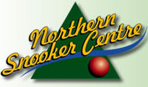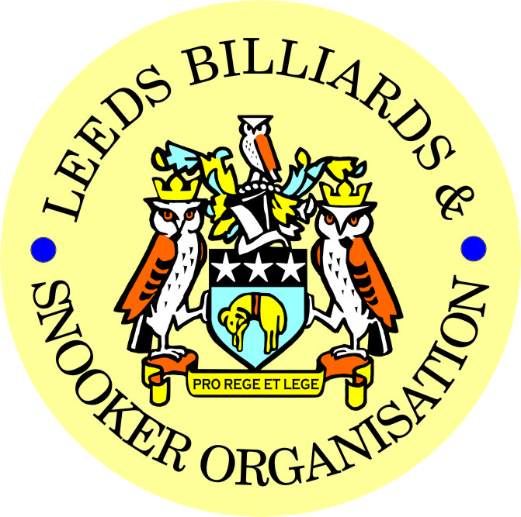

FINAL – 2019/20 LEEDS CITY SNOOKER CHAMPIONSHIP &
PRIZE PRESENTATION EVENING

FRIDAY 17th SEPTEMBER 2021 -7-30pm

NORTHERN SNOOKER CENTRE

** 2019/20 LEEDS CITY CHAMPIONSHIPS **

JUNIORS - UNDER 16’s SNOOKER:
Presented by ADT Flexibles (UK) Ltd.
WINNER: BAILEY FISHER | RUNNER-UP: RILEY FISHER
SEMI-FINAL: CASEY RATCLIFF | SEMI-FINAL: STAN MOODY
JUNIORS - UNDER 18’s SNOOKER:
“The Keith Weston Memorial Trophy”- Presented by ADT Flexibles (UK) Ltd.
WINNER: STAN MOODY | RUNNER-UP: RILEY FISHER
SEMI-FINAL: SAMUEL LEE STEVENS | SEMI-FINAL: BAILEY FISHER
JUNIOR HIGH BREAK: - “The Paul Hunter Memorial Trophy” – SAMUEL LEE STEVENS (73)

INDIVIDUAL SNOOKER:
WINNER: RYAN WALTON | RUNNER-UP: LIAM THEWLIS
SEMI-FINAL: LEWIS GILLEN | SEMI-FINAL: MALCOLM BILCLOUGH
PAIRS SNOOKER:
Trophy - Presented by ADT Flexibles (UK) Ltd.
WINNERS: SANDERSON LAM / LEWIS GILLEN | RUNNERS-UP: R WALTON / T DOHERTY
SEMI-FINAL: A RENNISON / D MYERS | SEMI-FINAL: L PULLEN / A. MASSEY
TEAM SNOOKER – “The Jim Fowler’s Trophy”:
WINNERS: HORSFORTH CONS ‘B’ | RUNNERS-UP: HORSFORTH CONS ‘A’

2019-2020 - *PRIZE PRESENTATION EVENING*

WEDNESDAY 13th OCTOBER 2021 – from 7-00pm

BRAMLEY BAND WMC

SNOOKER - “Veterans Trophy”  “The Rodney Sims Memorial Trophy”  Presented by the LBSO | REFEREES:  Officiated in 2019-20 LBSO Competitions:
WINNER: NOT CONTESTED | ANDY KITSON
RUNNER-UP: | MICHAEL DAVENPORT
 | PAUL MARLOW
PLATE WINNER: NOT CONTESTED | MARK BALL
PLATE RUNNER-UP:

** LBSO - SNOOKER LEAGUES **

Div: | CUP TITLE / WINNERS: | RUNNERS-UP:
Div A | The Yorkshire Evening News Shield:  TINSHILL & COOKRIDGE ‘A’ | EXCELSIOR SC ‘B’
Div B | The Clan Tartan Trophy:  GILDERSOME CONS ‘B’ | NORTHERN SC ‘A’
Div C | The John Dunning Trophy:  ADEL MEMORIAL | NEW MOORSIDE
Div D | The J. H. Lunn Cup:  MORLEY WMC & INST. ‘B’ | NORTHERN SC ‘B’
Div E | The Peter Nelson Trophy:  BELLE ISLE WMC ‘C’ | BELLE ISLE WMC ‘D’
Div F | The Peter Hawkyard Memorial Trophy:  BRAMLEY VILLAGERS ‘C’ | MORLEY CONS ‘A’
Div G | The J. McDonnell / J. Williamson Trophy:  HORSFORTH CONS ‘B’ | HAREHILLS LIBERAL ‘B’

“CHAMPION of CHAMPIONS”  “The Jim Williamson Memorial Trophy”  Presented by the Northern Snooker Centre | WINNERS: MORLEY WMC & INST ‘B’  (DIVISION D WINNERS)

LBSO LEAGUE & COMPETITIONS – SNOOKER HIGHEST BREAKS
HIGHEST BREAK TROPHY
Presented by ADT Flexibles (UK) Ltd. in 2019

Break | League / Competition | Player (Team)
119 | LEAGUE / DIVISION A | JOHNATHAN BAGLEY (EAST END PARK ‘B’)
115 | LEAGUE / DIVISION A | JOHNATHAN BAGLEY (EAST END PARK ‘B’)
104 | LEAGUE / DIVISION G | LIAM THEWLISS (HORSFORTH CONS ‘B’)
93 | LEAGUE / DIVISION A | LEWIS HARPER (EXCELSIOR SC ‘B’)
87 | LEAGUE / DIVISION C | ADAM RENNISON (HAREHILLS LAB ‘A’)
84 | LEAGUE / DIVISION D | MARK BALL (HORSFORTH CONS ‘A’)
51 | LEAGUE / DIVISION E | BRIAN HUSSEY (DENISON HALL ‘B’)

LEN LEE INVITATION SNOOKER – (Scratch):  “THE LEN LEE TROPHY”  Trophy presented by  ADT Flexibles (UK) Ltd  for 2020 | WINNER: RICHARD BINNS (BELLE ISLE WMC)  RUNNER-UP: DANNY DEAN (HAREHILLS LABOUR)

SNOOKER – SYKES CUP - Individual Handicap.
The “GEORGE SYKES CUP”

WINNER: AARON DRUMMOND  (NEW WORTLEY LABOUR) | RUNNER-UP: JAMES PEARS  (BARNBOW SOCIAL CLUB)
SEMI-FINAL: MARK KING  (BRAMLEY BAND CLUB) | SEMI FINAL: GRAHAM MARSDEN  (MIDDLETON CONSERVATIVES)

SNOOKER – LEN LEE PAIRS - Pairs Handicap.
The “LEN LEE CUP”

WINNERS: S. JENNINGS & S. CLARKE  (BRUNTCLIFFE WMC) | RUNNERS-UP: A. RENNISON & G. RENNISON  (HAREHILLS LABOUR)
SEMI-FINAL: T. DOHERTY & M. McGUIGAN  (DENISON HALL CLUB) | SEMI-FINAL: V. PARKIN & P. HALL  (MIDDLETON CONSERVATIVES)

SNOOKER - 3 MAN TEAM KNOCK OUT – Handicap.
The “Leeds & District Billiards League Snooker Cup”

WINNERS: NOT CONTESTED | RUNNERS-UP:
SEMI-FINAL: | SEMI FINAL:

** STAN BROOKE MEMORIAL COMPETITIONS **
(AGGREGATE SCORES – 3/4 FRAMES)

INDIVIDUAL SNOOKER – 3 FRAMES:

WINNER: ANDY FARRALLY  (BRAMLEY WMC) | RUNNER-UP: GARETH PRIESTLEY  (MAIN LINE SOCIAL)
SEMI-FINAL: MARK BALL  (HORSFORTH CONSERVATIVES) | SEMI FINAL: PETE RABY  (NORTHERN SC)
PAIRS SNOOKER – 3 FRAMES:

WINNERS: A. MASSEY & L. PULLEN  (NORTHERN SC) | RUNNER-UP: A. WINESTEIN & R.HIRST  (BRAMLEY WMC)
SEMI-FINAL: A. CONBOY & J. BAGLEY  (EAST END PARK WMC) | SEMI-FINAL: A.RENNISON & G.RENNISON  (HAREHILLS LABOUR)
TEAM SNOOKER – 4 FRAMES:

WINNERS: NEW WORTLEY LABOUR ‘A’ | RUNNERS-UP: MAIN LINE SOCIAL ‘A’
SEMI-FINAL: EDMUND HOUSE ‘A’ | SEMI-FINAL: MORLEY WMC & INST ‘B’

The “WINDSOR TROPHY” – 4 Man Team Handicap
Presented by ADT Flexibles (UK) Ltd.

WINNERS: DENISON HALL | RUNNERS-UP: BELLE ISLE WMC
SEMI-FINAL: BRUNTCLIFFE WMC | SEMI FINAL: HAREHILLS WMC

CONGRATULATIONS!
TO ALL PRIZE WINNERS FOR 2019-20

The LBSO would like to thank
- the Northern Snooker Centre for staging the final of the 2019/20 Leeds City Snooker Singles Championship and the 1st presentation of all 2019/20 Leeds City Champions on 17th September,
and
- Bramley Band Club for staging tonight’s 2nd presentation for the 2019/20 season.
**NO - AGM in 2021 (for 2019/20)**
DETAILS OF WHY ARE POSTED ON THE WEBSITE &
HAVE ALSO BEEN CIRCULATED TO ALL TEAM CAPTAINS

CURRENT LBSO COMMITTEE MEMBERS
PRESIDENT – CHRIS WILLIAMSON
CHAIRMAN – ANDY TAFFINDER
VICE CHAIRMAN –
LEAGUE SECRETARY – PAUL GRIMES
COMPETITION SECRETARIES – MARK BALL & PAUL MARLOW
GENERAL SECRETARY / TREASURER – BOB PATTERSON

OTHER DATES FOR YOUR DIARY:
20th OCTOBER 2021 – START OF THE 2021/22 LEAGUE SEASON

Produced By
Kindly Sponsored by the ‘NORTHERN SNOOKER CENTRE’

